How to adjust the setting for multiagent simulations
By Arsham Mostaani – Affiliated with SnT - Supervised by Bjorn Ottersten – Date : 11/08/2022

ESAIC – SAIC

Finding the right functions and scripts

- The parameter setup is “Parallel_simulator_2phase_encoded_MA ”
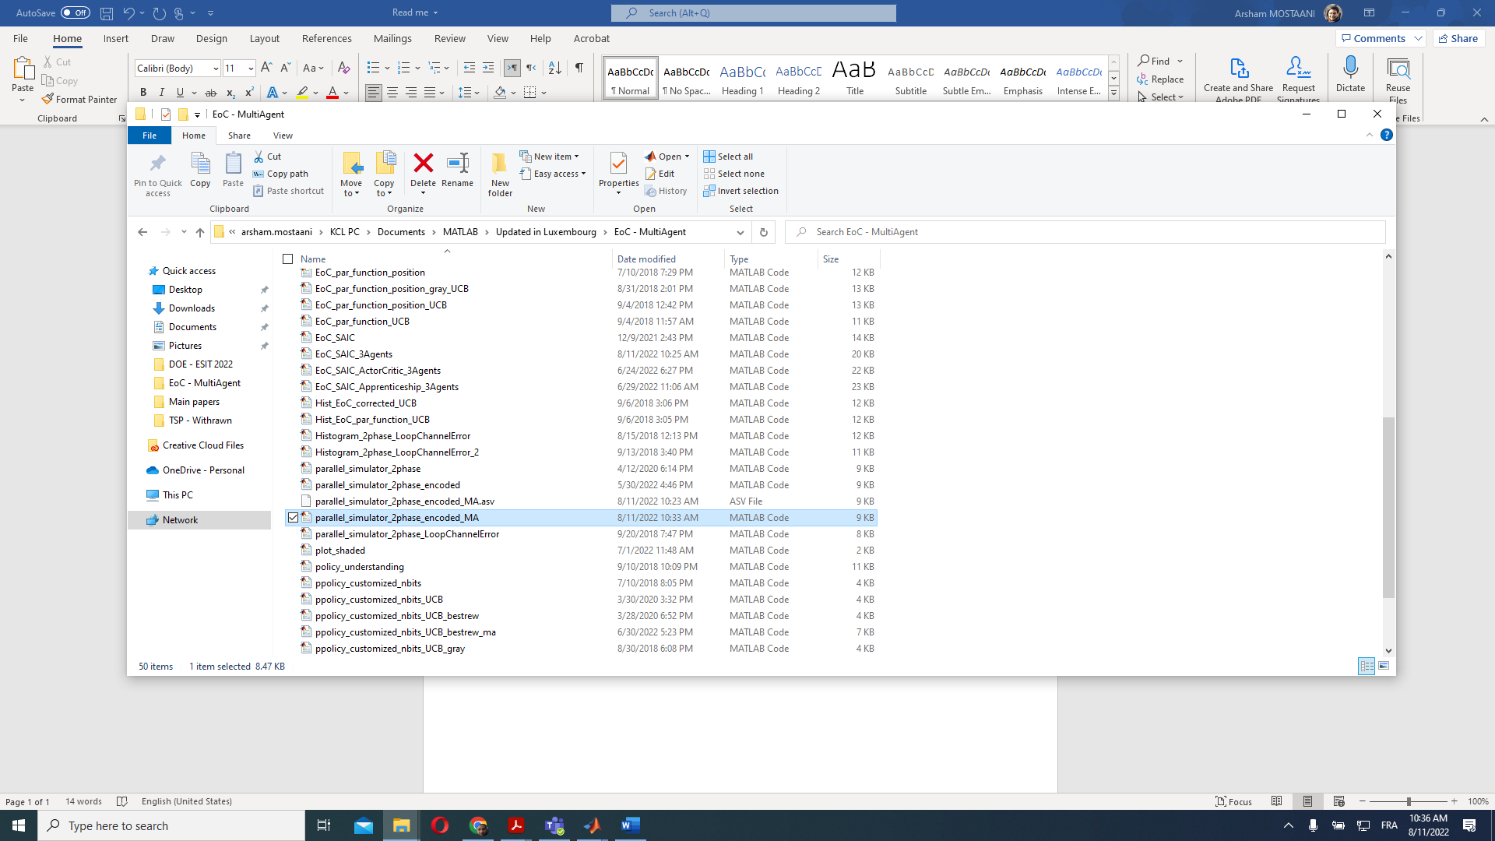
- The parameter setup is control panel that gives the user all sorts of control facilities to adjust the simulations to their needs.

- “EoC_SAIC_3Agents ” is a function wrapper that encapsulates all functions that interact with each other to completely simulate one episode of training.

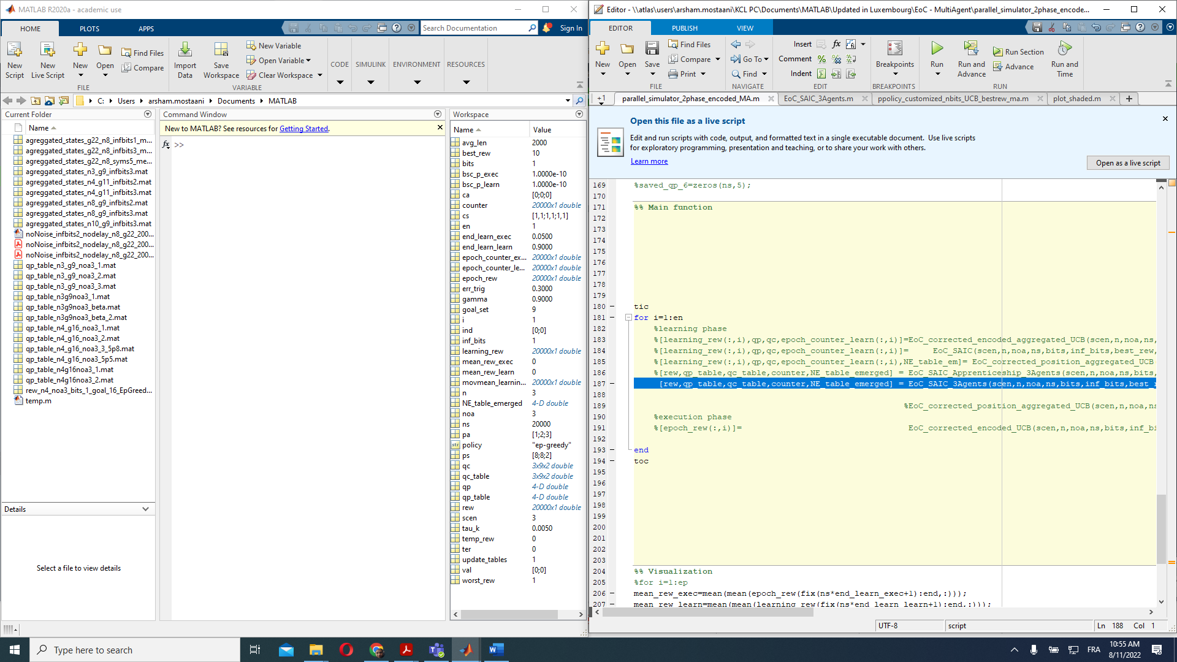

- To have nice looking simulation results you can also use the “plot_shaded” function, which plots the reward signal together with a shaded area of its variance. This is done such that the reward variance through a time window of the existing epoch is depicted in the form of the width of the shades – find out more in the code details and comments.
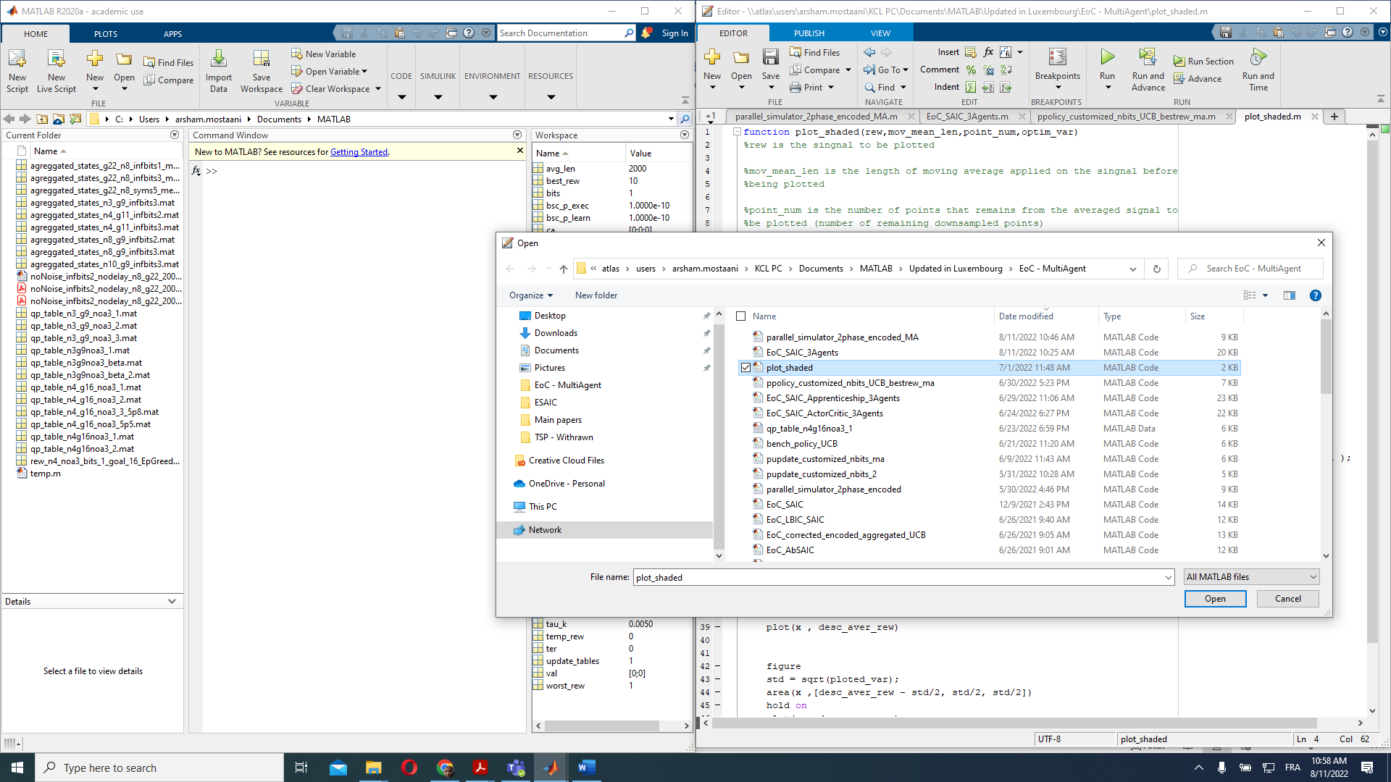

- All these scripts and functions are available in the folder:
\\atlas\users\arsham.mostaani\KCL PC\Documents\MATLAB\Updated in Luxembourg\EoC - MultiAgent
This folder is on the server of the university and is frequently backed up.

Adjustment of the control panel

- Select the number of grids in each direction e.g., $n=3$ is selected when you want a 3x3 grid world
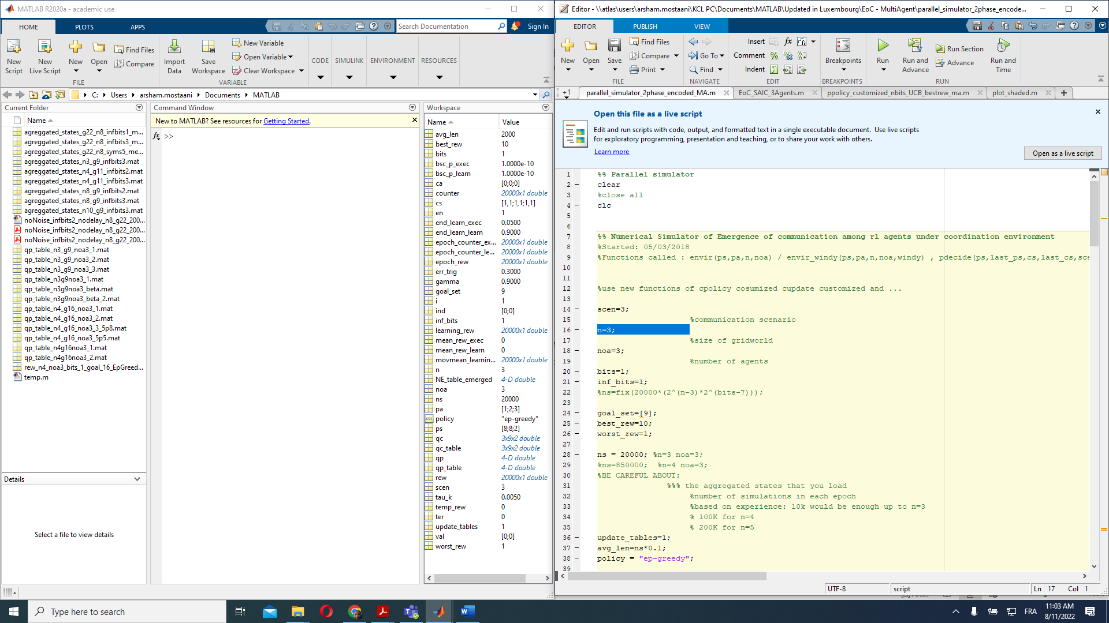

- Select the number of agents with the parameter noa (standing for the Number of Agents)
noa=3;

- Select the number of communication bits – in the case of task-oriented quantization bits and inf_bits should have similar values

bits=1;
inf_bits=1;

- According to the size of the grid-world and the number of quantized bits, load the right quantizer inside the wrapper
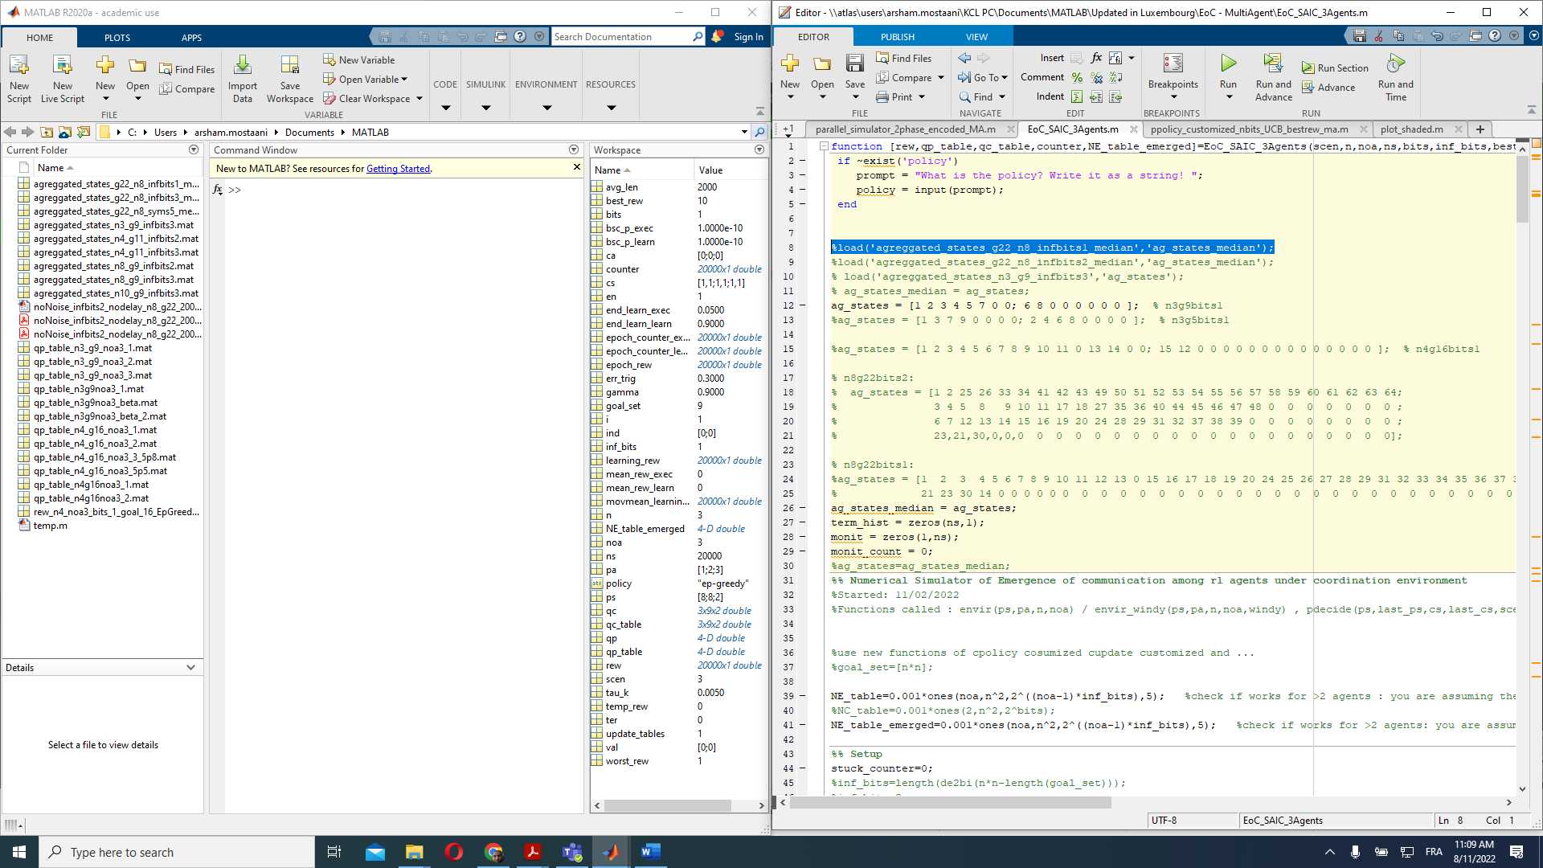

- Select the right goal set/location
goal_set=[9];

- Update tables = 1 – This parameter should only be zero when using Apprenticeship learning wrapper.
update_tables=1;

- Choose the right policy – we have obtained very good results with decaying epsilon greedy:
policy = "ep-greedy"

- Check your rewarding scheme – the default setting is adjusted according to our paper:
“Task-Oriented Data Compression for Multi-Agent Communications Over Bit-Budgeted Channels” – This is the TSP paper being withdrawn and submitted to OJCOMS.
Accordingly, the common reward signal increases exponentially as the number of agents arrived at the goal point are increased.

